Please follow below steps to install Katalon in windows machine.

1. Browse <https://www.katalon.com/> and click on sign In button.

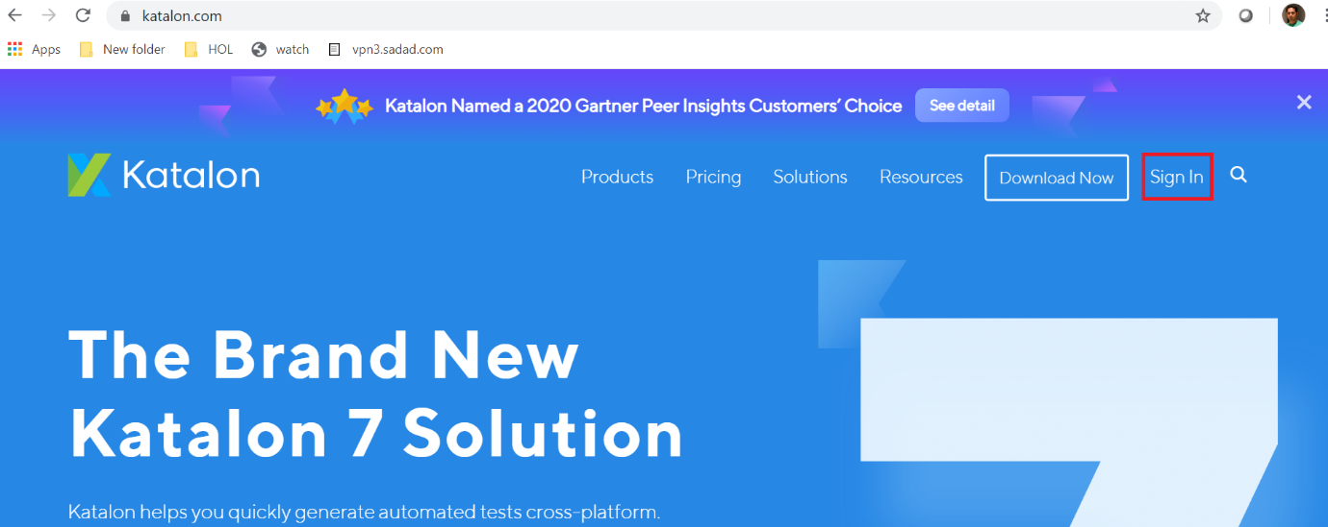

1. If you do not have Katalon account then Click on ‘Sign Up’ button but if you already have Katalon account then enter Email and password which you have mentioned during ‘Sign Up’ for Katalon account then click on ‘Sign In’ button.

[deepak.applabs@gmail.com](mailto:deepak.applabs@gmail.com)

Passw0rd

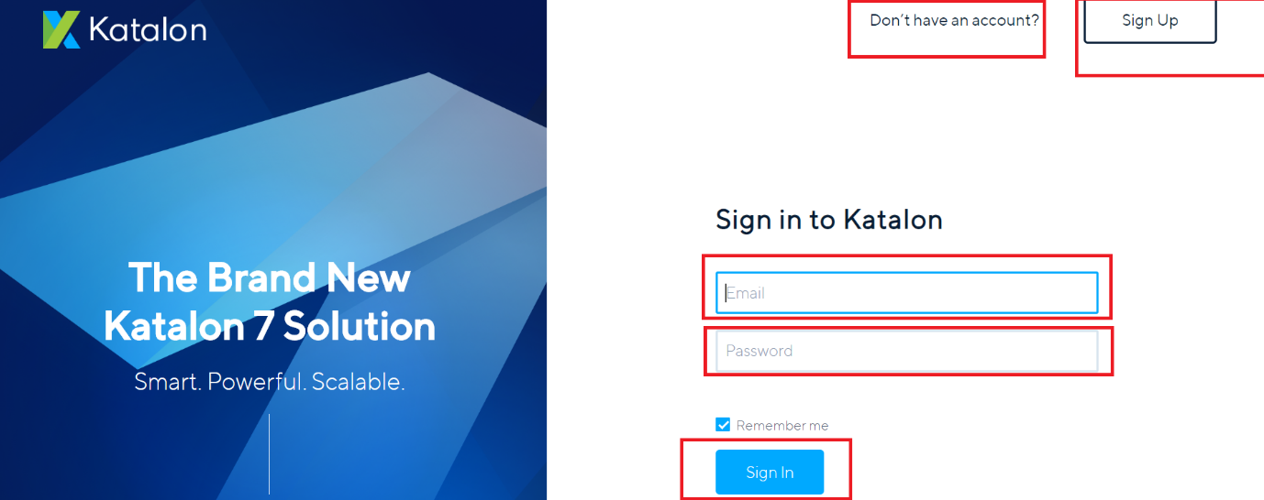

1. After Sign into Katalon, click on ‘Download Now’ button.

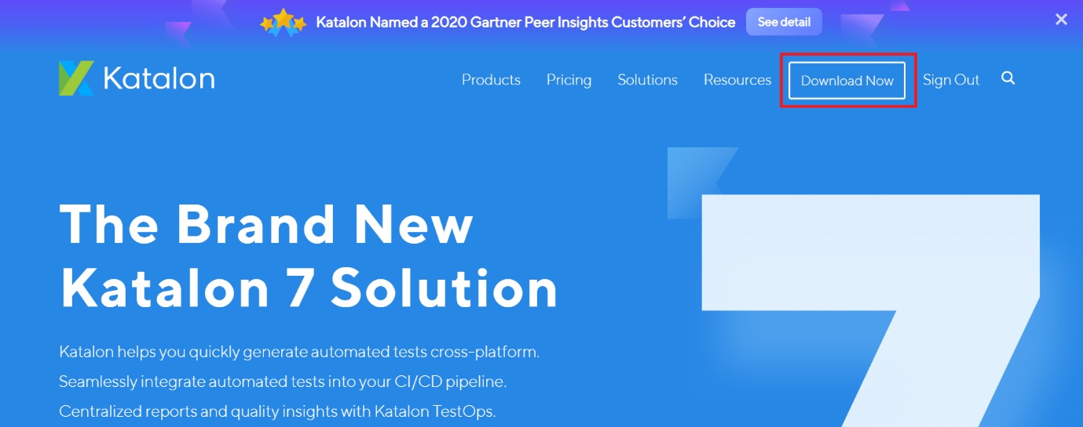

1. Select your System OS (Example :: Windows64bit) from Katalon Studio drop down list and Click on ‘Download’ button.

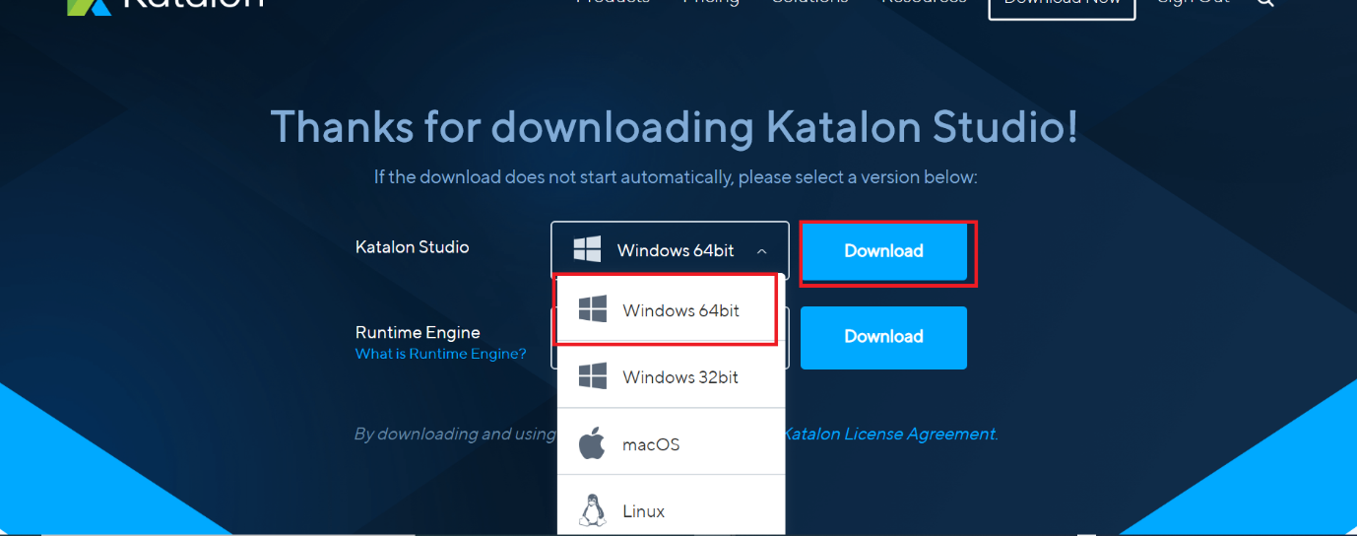

1. Once download is over, place that zip folder to any path ( Example : C:/Katalon) and extract the zip file.



1. Click on Katalon to open Katalon successfully on windows machine.

